Measures taken by category

Team travel
The Pelicans league team has given up flying and will commute all of their away games on the bus. Reissu Ruoti, who is responsible for the team's transport and is one of the main partners, uses only renewable fuels made from waste fats and vegetable oils, ie. they are classified as hydrotreated fuels, for Pelicans' guest game trips. The cars used by Reissu Ruoti for transport are also Euro 6 rated, which has the lowest emissions and the best emissions rating.

Movement of players and other staff
Like Reissu Ruoti, one of the main goals of the co-operation agreement with Mega-Auto, one of Pelicans' main partners, has been to help the Lahti club achieve the goal of carbon neutrality. The carbon footprint of the car fleet has decreased by 33% from last season and will continue to decline in the future as the club's car fleet updates. Currently, the car fleet is a mix of gasoline-powered, hybrid and electric cars.

In addition to private cars, Pelicans players and other staff have had access to an electronic shared car since last year. An electronic van will be coming to Pelicans' restaurant operations this season.

Every year from spring to autumn, Pelicans players have the opportunity to use the club's bicycles, which are also actively used by younger players in particular. Several of the club’s staff now also complete their commutes by public transport, walking, electric scooters, or biking.

Ice rink heat and electricity
The heating of Isku Arena has undergone a major change for the better when Lahti Energia, one of Pelicans' main partners, gave up the use of coal in the production of district heating. The next step will be experienced on January 1, 2022, when the management company Spatium will switch to 100% renewable district heating to Isku Arena.

The only small backpack on Pelicans ’carbon neutrality journey has been seen in electricity generation. Emissions from electricity production have increased slightly since the change of Isku Arena's electricity seller. More environmentally friendly alternatives are still available and the introduction of these has already been discussed with Spatium, which is responsible for the operation of the hall. The changes will most likely be seen once the market situation has calmed down.

Ice machine and waste
Isku Arena's ice machines have been renovated, which has also reduced their emissions. The changes are not yet reflected in the report now published.

In terms of waste, Pelicans has renovated waste points outside and inside the hall during the project and invested in sorting and recycling. For example, all the intact equipment of the league team is utilized for further use, and a new use has been found for broken rackets, among other things, as hangers for Game Worn collectible shirts.

Audience movement
Emissions from public mobility fell radically last season due to the Covid 19 pandemic and the resulting public restrictions. Pelicans has tried to encourage its audience to come to game events in a sustainable way and has run various campaigns with, among others, traffic in the Lahti region (cheaper tickets for those coming to the match) and Reissu Ruoti (joint transport from nearby towns). The number of people attending matches in sustainable ways has also clearly increased, for example with the increase in the use of electric scooters.

Compensation
We have offset the rest of our carbon footprint (130 tCO2eq) through projects certified by the internationally recognized Gold Standard.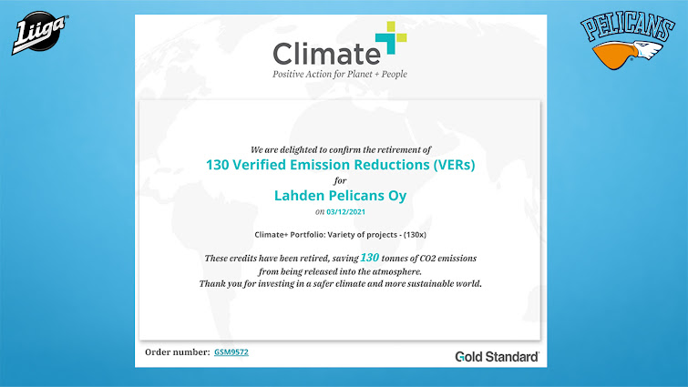

Other measures
Although only limited areas were considered in the calculation, Pelicans has sought to reduce its carbon footprint in all of its operations and plans have been made long into the future. In the big picture, Pelicans aims to continue the carbon neutrality process and to be carbon neutral in the future for the entire organization and all its operations. Below are examples of other measures already taken.

All of Pelicans' home arenas logo carpets have been refurbished by partner Lindström, and the carpets found in the arena are now made from 100% recycled fiber made from plastic bottles.

The paper towels for the toilets in Isku Arenas fences and VIP facilities have been replaced with more environmentally friendly towel rolls, and the same will be done in all Isku Arenas facilities.

In the pens and VIP rooms of Isku Arena, napkins made of IRIS recycled material are used, which are made of high-quality REPREVE® fiber, which in turn is made of plastic bottles.

The tablecloths for the VIP rooms come from Lindström and their environmental friendliness has been honed to the brim with the washing process and transport arrangements.

The Pelicans league team and office staff have stopped using disposable cups and mugs. Team members have their own labeled thermoplastic cups and porcelain coffee cups, which with this, the amount of daily waste has dropped significantly.

Pelicans' restaurant operations favor local producers and domestic ingredients.

Pelicans play a significant communicative role
The most significant role of the Lahti club in its carbon neutrality goal has been communicative. Pelicans was already heavily influencing the choice of Lahti as the European Capital of Environment, when the team's players were present in Oslo, where all the candidate cities were present. Pelicans garnered plenty of national and international visibility in January of this year, playing one of their home matches in special shirts, each unique and highlighting a variety of climatic acts.

The media visibility has otherwise been enormous during the process, as Pelicans ’online articles on climate work have reached more than 200 million people internationally. Isku Arena has also hosted European TV production groups extensively this year. In addition to the largest domestic and European media, media visibility has been also in the United States and Asia.

Pelicans has also diligently published various content on social media related to environmental friendliness and has sought to encourage others by setting an example.
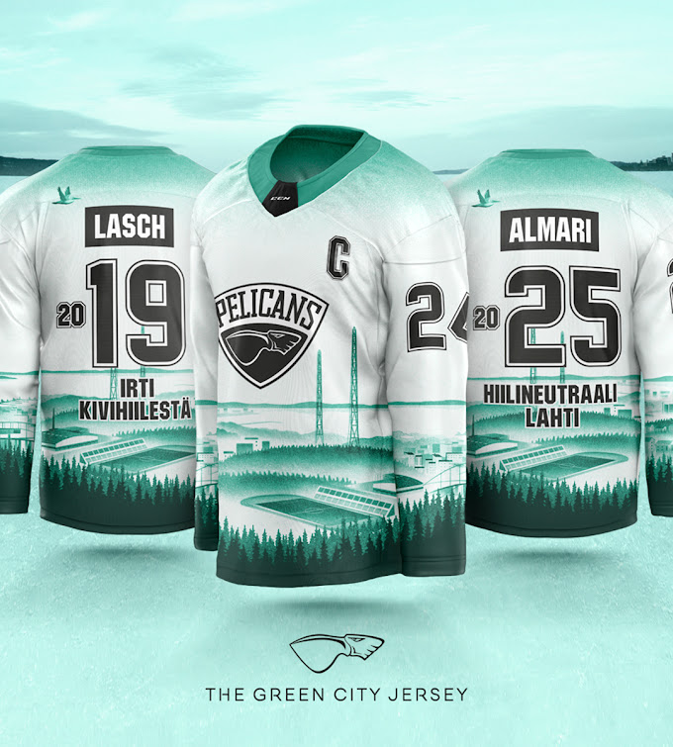

Comments and future actions
The Pelicans Lahti have agreed with LUT University on the calculation of the carbon footprint in the spring of 2022, which now takes into account entities that have been excluded from the delimitation, such as the carbon footprint of restaurant operations.

12 electric car charging points are coming in front of Isku Arena, which will also make it easier to increase electric car capacity. In match events, charging points are of course also available to spectators.

Despite the milestone that has now been reached, Pelicans will continue to work for the climate and encourage other sports players to work with climate by example.

CALCULATION OF THE CARBON FOOTPRINT OF THE LAHTI PELICANS LEAGUE TEAM
11/22/2021
Ville Uusitalo, Assistant Professor
LUT University

This condensed report describes the limits, key assumptions and main results of the calculation of the carbon footprint of the Lahti Pelicans league team. The calculation of the carbon footprint was carried out for the league period 2017-2018 and the key changes in the carbon footprint were calculated for the period 2020-2021.

Starting points and boundaries of the calculation
The aim of this calculation was to calculate the carbon footprint of the Lahti Pelicans league team for one league season based on ISO life cycle assessment standards. In this study, the same calculation limits were chosen as in the study made by Hepo-Oja (2018) for the Finnish Ice Hockey League. It’s good to note that it’s not entirely clear which areas should be included in a league team’s carbon footprint. The areas involved in this review are the movement of the team on gaming trips, the commuting of players and staff, and the movement of the audience to home matches. In addition, the review includes the league team's share of Isku Areena's use of electricity, heat and ice machines, as well as waste management. Equipment, for example, is also an integral part of the league's activities, but it was not yet possible to include its share at this stage due to a lack of information on their carbon footprint. The calculation can be refined later for the missing areas.

Calculating the carbon footprint of the Pelicans league team for the period 2017-2018
A survey of spectators (346 responses) and staff (12 responses) was conducted on modes of transport, travel and carpooling. Based on the responses, average modes and distances were calculated. Emissions from these were calculated taking into account emissions from the use and production of fuels for different modes of transport and by scaling the results to cover the entire league period and the number of spectators and employees. The total audience in home matches was obtained from the League statistics. In terms of team travel, the total bus and air travel for the season was combined with emission factors describing these modes. In addition, the maintenance van was traveling on away game trips and its emissions have been included in the review. The ice hall's electricity and heat consumption data were collected from the ice rink portal and the emissions from their production were calculated using the emission factors obtained from the local district heating and electricity supplier. For the operation of the ice machine, the annual consumption of propane was obtained and the related emissions were calculated using the emission factor for propane combustion. The league team was allocated a share of these emissions according to the occupancy rate of the ice rink. For waste, data on waste volumes were collected and related emissions were calculated using the emission factors of WWF's climate calculator.

Changes in the carbon footprint of the Pelicans league team for the period 2020-2021
This section calculated how much the carbon footprint of the Pelicans League team was reduced as a result of the conversion measures and the exceptional circumstances caused by COVID-19. As for game trips, the team will end its flights and all trips were made by bus, increasing the total number of buses. However, the bus switched to diesel based on renewable raw materials, which is promised a 90% reduction in its own carbon footprint compared to fossil diesel. In the case of the ice rink, the use of coal was abandoned in local district heating production, which reduced emissions from district heating production. With regard to electricity, the electricity sales company changed, which increased the calculated emissions from electricity generation. According to league statistics, Pelicans ’audience fell by 92% due to the COVID-19 pandemic, which played a major role in the emissions caused by the movement of the audience. For other factors, no changes compared to the 2017-2018 calculation were considered.

Carbon footprint of the Lahti Pelicans league team
The following figure shows the carbon footprint of the Pelicans League team with the limitations and assumptions presented in this summary report. The total carbon footprint in 2021 is 130 tCO2eq and without public movement it is about 100 tCO2eq.
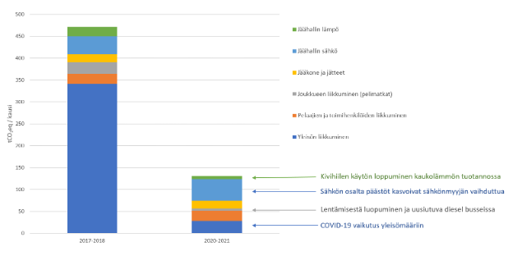
Figure 1: Carbon footprint of the Pelicans league team and its changes

The pursuit of low carbon is typically an ongoing process that can be refined and improved as knowledge accumulates. In its own approach, Pelicans implemented the model recommended by the UN for sports players. In its first phase, the carbon footprint of the current state of operations is measured and an understanding of what it causes and, on the other hand, what uncertainties and information gaps are involved in the calculation. Emissions that can be avoided (eg. flying) are then avoided and reduced and replaced by lower emissions (eg. renewable fuel for buses). After this, the remaining emissions that cannot be completely eliminated can be compensated if carbon neutrality is to be achieved. After that, the key role is to pass on information and tell about one's own process. One of the key objectives of this review is to raise awareness among sports players and to encourage them to reduce their emissions.

As the calculation report is seasonal, not all measures in the lower emission direction will be reflected in the published report.

